Keil MicroVision Project Setup

# New Project Creation

Start up Keil MicroVision 4

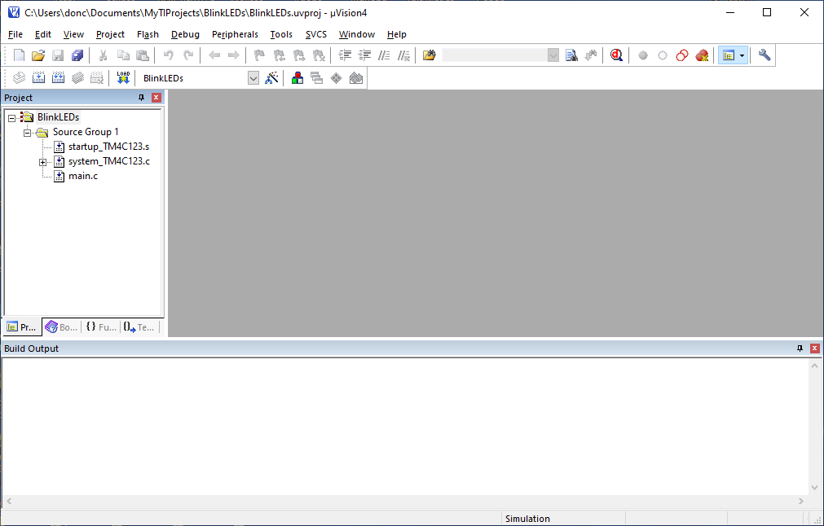

Move to Working Area, and create New Directory with Project Name

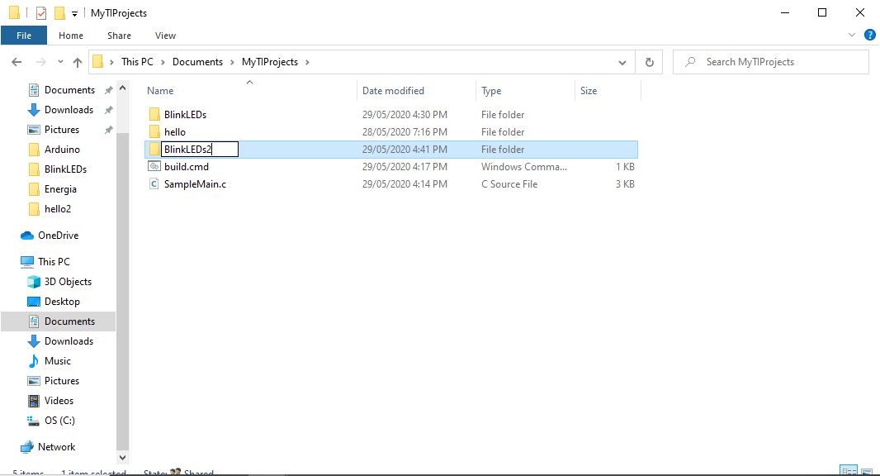

Select MicroVision Project -> New MicroVision Project

Navigate to new Folder, and save project file with Project Name

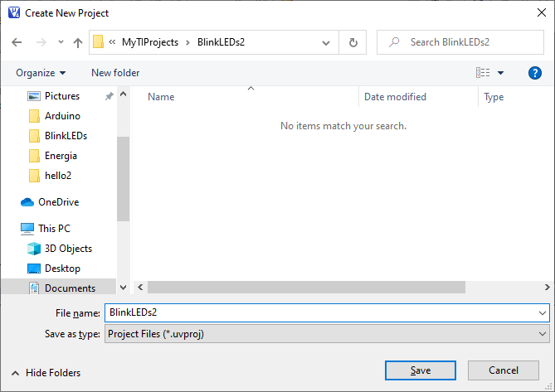

On click Save, select target device as TM4C123GH6PM

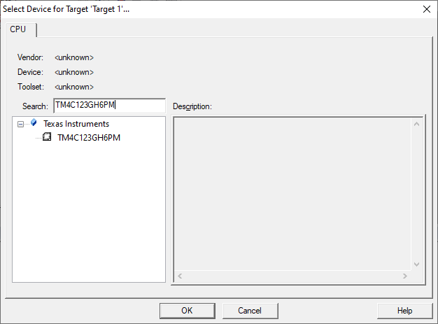

Agree to copy .s target files

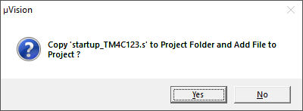

We now have

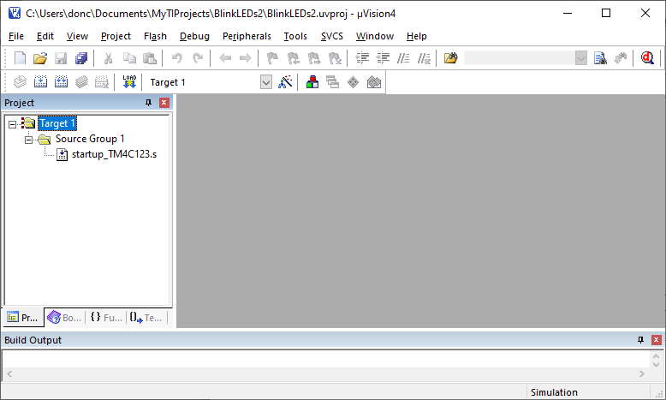

Now add startup *.c file. Right click Source Group 1, select Add Existing Files …

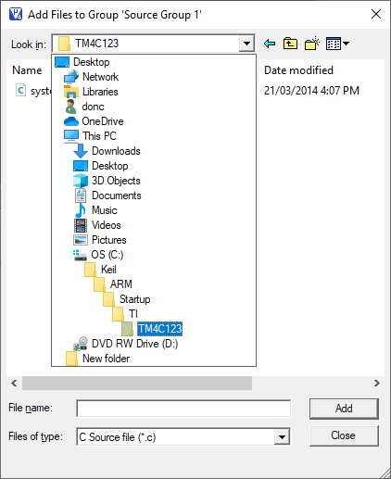

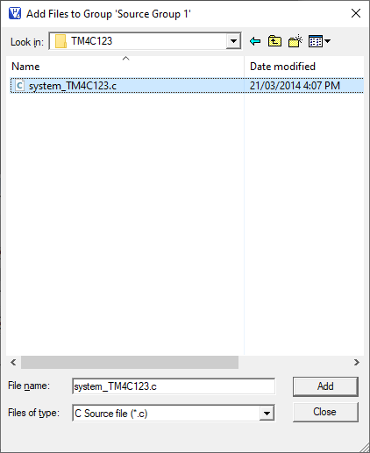

Select “Add”, then “Close”

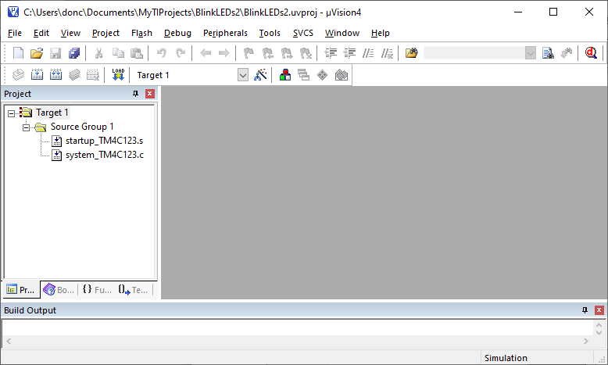

Now add a main.c file to project directory

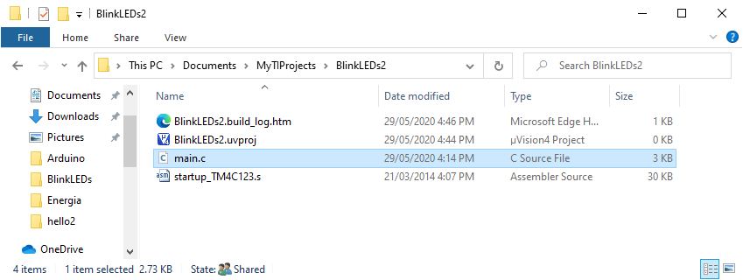

There is an example main program that illuminates LEDs depend upon Push Bitton Switch Status, in top level directory

Add to Project by Right Click “Source Group 1”, -> Add Existing …

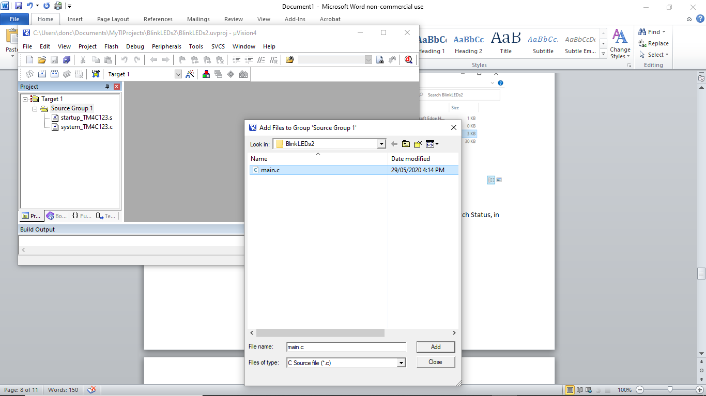

Find main.c, click Add, then Close to get

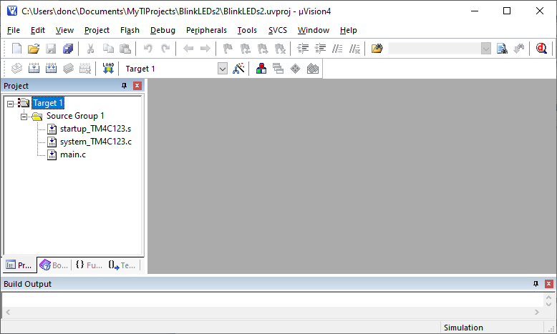

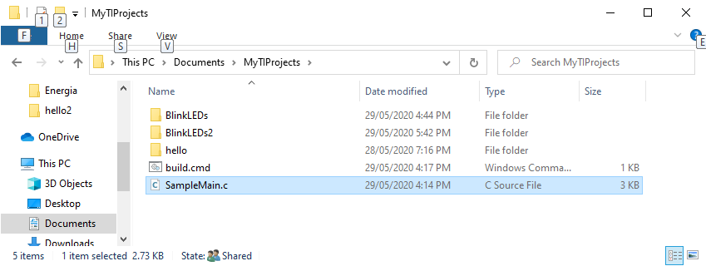

Now copy the template build.cmd from the top level directory to the project folder

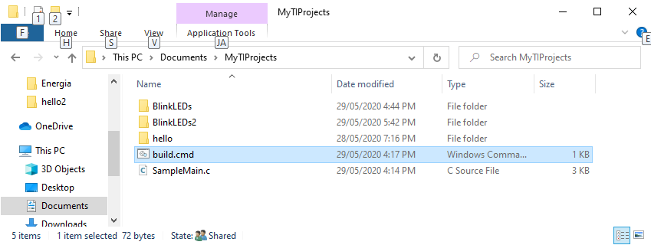

Project Folder with build.cmd

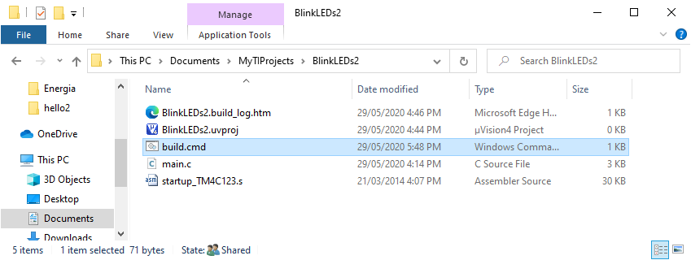

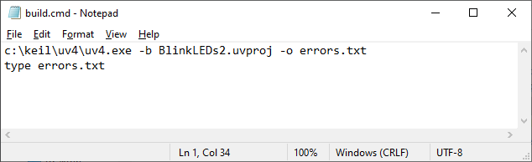

“build.com” edited to include Project Name

Change Floating Point Option to Not Used, in Project -> Options for Target, Target Tab

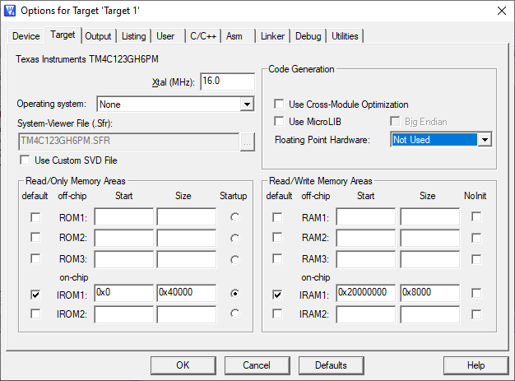

Set the “Use” field to Stellaris ICDI

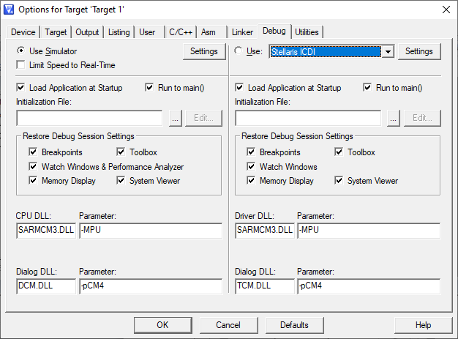

To rename Target 1

Project -> Manage -> Components …

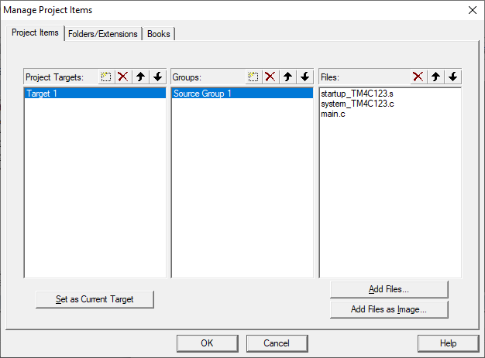

Double click “Target 1”, and rename

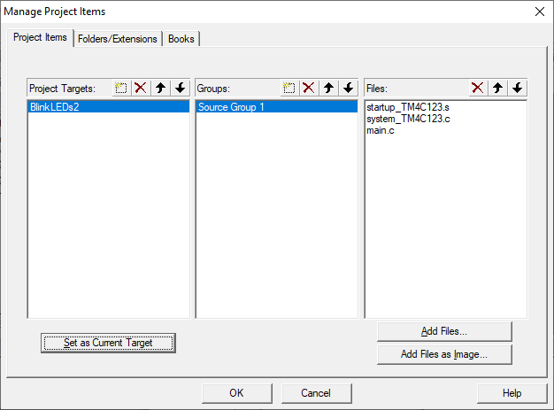

Click “OK”, to get

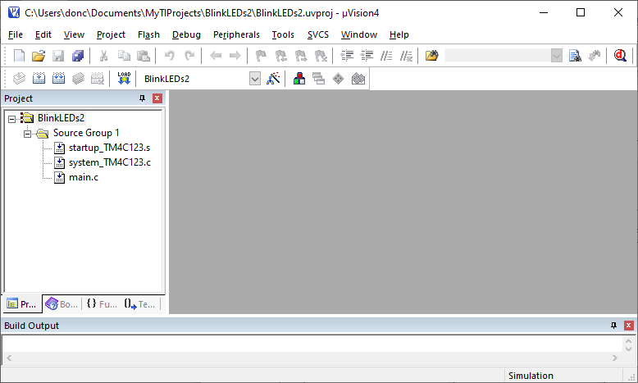

# Compiling Program

Menu “Project” -> Rebuild all TargetFiles

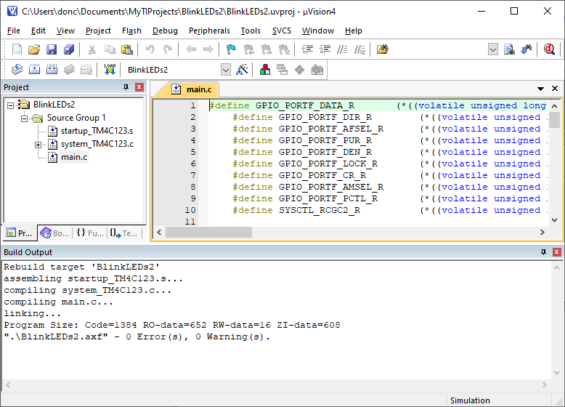

To download program, menu “Flash” -> Download

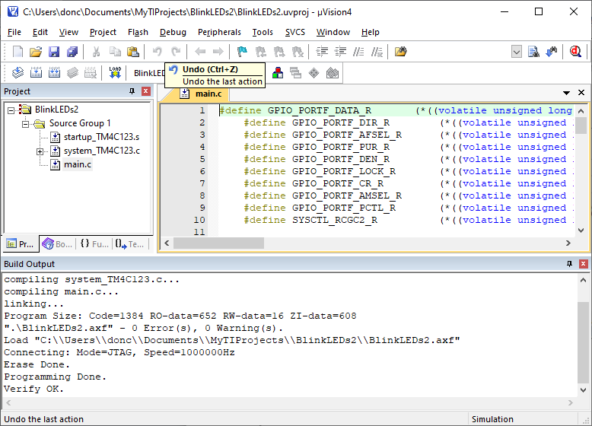

Reset Launchpad board, and press one or more switches

SW1 is RED LED, SW2 is GREEN LED, both SW1 and SW2 is BLUE LED